Software Development Life Cycle (SDLC)
1. Introduction
The Software Development Life Cycle (SDLC) is a structured process used by engineering teams to design, develop, test, deploy, and maintain software systems. It ensures that the final software product is high-quality, reliable, scalable, and aligned with business requirements. SDLC breaks the development process into well-defined phases, allowing teams to manage complexity, reduce risks, and ensure timely delivery.
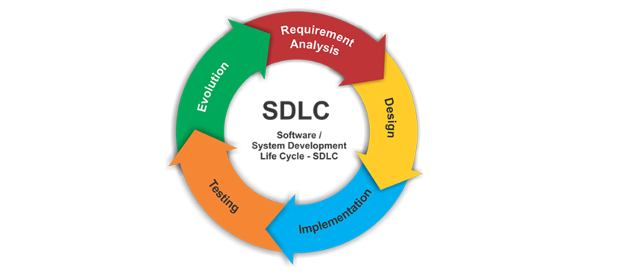

2. Requirement Phase
2.1 Requirement Gathering
The SDLC begins with understanding what the client or Product Owner (PO) needs.
Activities include:
- Collecting textual requirements
- Understanding user expectations
- Reviewing business workflows
- Identifying limitations, risks, and acceptance criteria
2.2 Wireframes & Abstract
Wireframes serve as visual blueprints:
- Shows screen layouts
- Defines user interactions
- Helps bridge communication between design & engineering teams
The abstract summarizes the project vision, objective, and scope, ensuring all stakeholders share the same understanding.
2.3 Approvals
Finalized requirements are approved by:
- PO (Product Owner)
- Client stakeholders
- Business analysts
This ensures the development begins on a solid, agreed-upon foundation.
3. Technical Documentation Phase
3.1 Role of TL / Architect
The Technical Lead (TL) or Solution Architect prepares the Technical Design Document (TDD), which includes:
- System architecture and flow diagrams
- Class structures
- Interfaces and inheritance patterns
- Module breakdown
- Component-level design
3.2 Multiple Reviews
The technical document undergoes:
- Peer review
- Architecture review
- Security and performance validation
This ensures scalability, maintainability, and compliance with engineering standards.
3.3 Key Technical Components
A standard technical document defines:
- Number of classes and responsibilities
- Interfaces and their contracts
- Inheritance structure for code reuse
- Components with input/output definitions
- Modules arranged logically for deployment
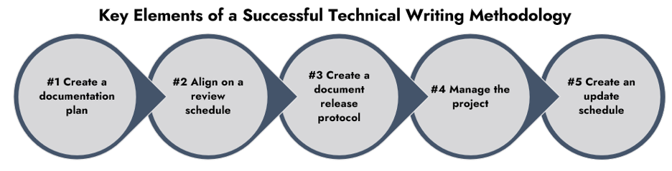
4. Coding Phase
4.1 Development Begins
Once the design is approved, coding starts. Usually:
- SSE (Senior Software Engineer) handles complex components
- SE (Software Engineer) handles modules, integration, and unit tests
4.2 Coding Standards
Teams follow:
- Naming conventions
- Layered architecture
- Clean code practices
- Version control (Git) policies
- Unit testing and code coverage requirements
4.3 Code Review & Integration
All code is reviewed by seniors or TLs before merging to the main branch.
Continuous Integration (CI) pipelines ensure:
- Automated build
- Static code analysis
- Unit test execution
5. Testing Phase
5.1 QA Testing
After development, the build is deployed to a QA Server for testing.
Types of testing include:
- Functional Testing
- UI/UX Testing
- API Testing
- Integration Testing
5.2 Bug Identification
QA engineers raise bugs in tracking tools (Jira, Bugzilla, Azure DevOps).
Bugs may relate to:
- Incorrect functionality
- Performance issues
- UI defects
- Integration errors
- Security vulnerabilities
5.3 Fix & Re-testing
Developers fix bugs → QA re-tests → Approves for next environment.
6. Staging Environment
The Staging Environment simulates a real production-like environment.
Here, advanced testing includes:
6.1 Regression Testing
Ensures new changes do not break existing functionality.
6.2 Load Testing
Evaluates system performance under:
- High user load
- Peak traffic
- Stress and endurance conditions
6.3 Automation Testing
Automated scripts verify:
- Repetitive test cases
- Functional flows
- Critical end-to-end scenarios
7. UAT (User Acceptance Testing) Environment
In UAT:
- Clients/business users validate the system
- Real-world workflows are tested
- Final approval for deployment is obtained
UAT ensures that the product meets business expectations before go-live.
8. PPE – Pre-Production Environment
PPE is the final dry-run environment before production.
Here, teams verify:
- Deployment scripts
- Database migrations
- API keys, secrets, and configurations
- Production readiness
It acts as the last checkpoint.
9. Production Environment (PROD) – Go Live
When all approvals are complete:
- Code is deployed to the Production Environment
- System becomes live for end users
- Monitoring tools track performance, logs, and errors
This is the official launch phase of the software.
10. Maintenance & Bug Fixes
After deployment:
- New bugs may appear in real usage
- Engineers provide patches, updates, and performance enhancements
- Maintenance ensures reliability and continuous improvement
Common activities include:
- Hotfix releases
- Monitoring alerts
- Performance tuning
- Feature improvements

